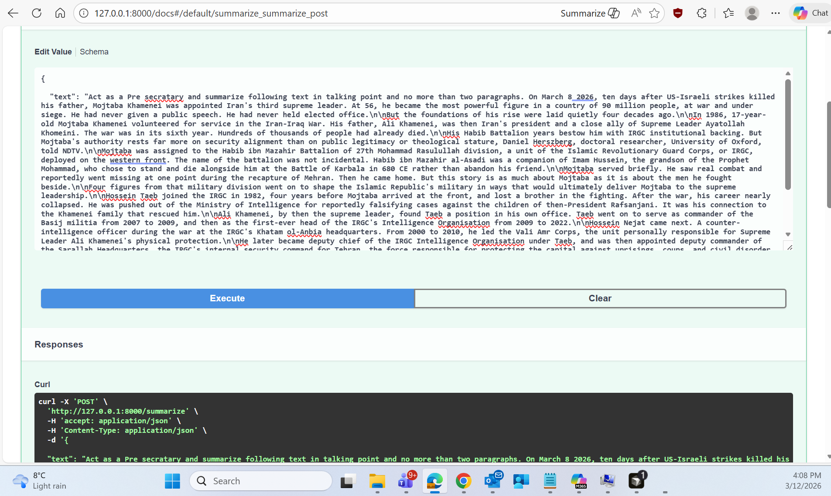
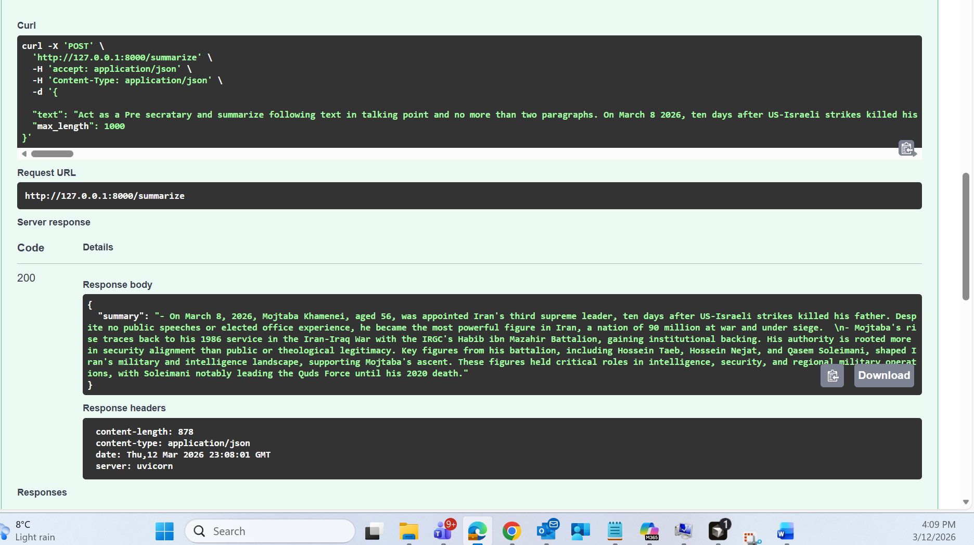

- On March 8, 2026, Mojtaba Khamenei, aged 56, was appointed Iran's third supreme leader, ten days after US-Israeli strikes killed his father. Despite no public speeches or elected office experience, he became the most powerful figure in Iran, a nation of 90 million at war and under siege. \n- Mojtaba's rise traces back to his 1986 service in the Iran-Iraq War with the IRGC's Habib ibn Mazahir Battalion, gaining institutional backing. His authority is rooted more in security alignment than public or theological legitimacy. Key figures from his battalion, including Hossein Taeb, Hossein Nejat, and Qasem Soleimani, shaped Iran's military and intelligence landscape, supporting Mojtaba's ascent. These figures held critical roles in intelligence, security, and regional military operations, with Soleimani notably leading the Quds Force until his 2020 death.

